Bridgepoint Parts Catalog

Section XVIII: Heat Exchangers Page 1

PP61-950546

Heat Exchanger – Preheater

Prochem Blower Exhaust

(Prochem Part # 61-950695)
Top Barb Faces Right
Bottom Barb Faces Left
Front Preheater: Bruin, Lancer, Bearcat Performer & Performer 405
Rear preheater: Bruin II & Lancer II

PP57-520074

Coil Assembly – Exhaust Heat Exchanger

Prochem: Trailblazer, Bruin, Bruin II, Bearcat, Legend,
Legend SE, Performer & Performer 405
Bridgepoint: Saber & Lancer

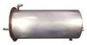
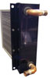

PP43-807086

Gasket – Rear Flange

Exhaust Heat Exchanger
Use with PP57-520074



PP61-950696

Heat Exchanger – Preheater

Prochem Blower Exhaust
Top Barb Faces Left
Bottom Barb Faces Right
Single Preheater: Trailblazer, Legend, Legend SE, Saber & Saber 2000
Front Preheater: Bruin II & Lancer II
Rear preheater: Bruin, Lancer, Bearcat,
Performer & Performer 405

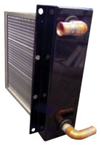

PP56-501759

Cover – Heat Exchanger End

With Catalytic Element
Use on PP57-520074 with gasket
PP43-807086

PP61-950886

Heat Exchanger – Preheater

Prochem Blower Exhaust

Both Barbs Face Same Direction

Single Preheater: Blazer & Blazer Plus

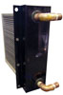

PP58-700028

Heat shield – Catalytic Heater

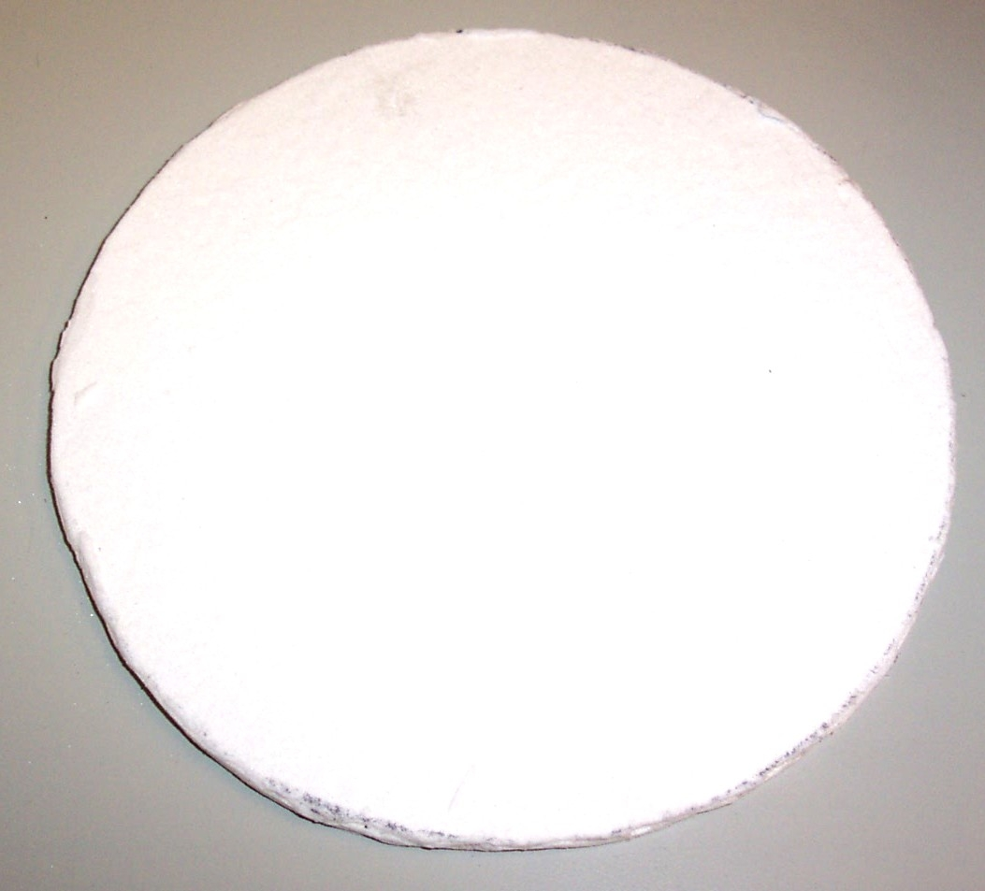

PP43-807081

Gasket – Preheater Cover

Fits PP61-950546, PP61-950696
PP61-950886 & PP61-951278

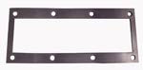

PP52-501654

Nut Adapter Bushing

Heat Exchanger Fitting
Use with PP57-520074

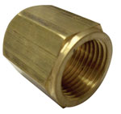

PP52-501643

Cover - Heat shield

Catalytic Heater

PP57-520085

Heat Exchanger – Tube & Shell

Prochem: Bruin II, Performer 805 & PTO
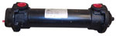
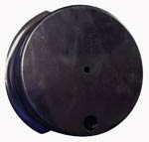

PP42-902212

Gasket – Engine Exhaust to

Heat Exchanger

PP41-809122

Air Pump

Pulley: PP52-501647

Prochem: Used on all Catalytic Truck mounts.
Bridgepoint: Saber & Lancer
Hydramaster: Maxx 450 & Maxx 470
(Uses different pulley – 109-083 & spacer 154-092)
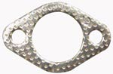
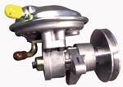

PP57-520093

Heat Exchanger – Exhaust

Blazer Plus

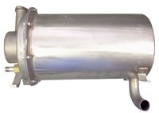

Bridgepoint Parts Catalog

Section XVIII: Heat Exchangers Page 2

PP57-520073

Heli-Coil Heat Exchanger

Water to Water
Prochem: 800A, Bearcat, Performer, Performer 405, Everest, Everest HP & PTO

791188

Heat Exchanger – Preheater

Copper
Prochem: Everest 408 & 650

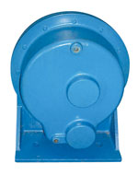
TEMPORARY
STOCK ITEM

791189

Heat Exchanger – HP SS
Prochem: Everest 408 & 650

TEMPORARY
STOCK ITEM
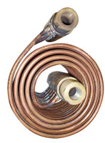

PP57-520033

Coil - Heli-Coil Heat Exchanger

Replacement Coil

36238

Grommet HE Cover

1/2” ID x 1-1/8” OD
TEMPORARY
STOCK ITEM

PP43-807051

Gasket – Manifold Heli-Coil

Fittings – (Requires two)
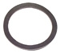

86313690

Gasket – Single HX Cover
Prochem: Legend GT & Peak GTX

PP43-807049

Gasket – Cover Heli-Coil

TEMPORARY
STOCK ITEM

86308930

Gasket – Double HX Cover
Prochem: Blazer GT & Legend GT

PP57-520010

Heater Coil – Oil Fired Heater
Prochem: 100A, 150
& Oil Fired TM

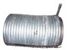
TEMPORARY
STOCK ITEM

86318840 Heat Exchanger – Preheater

Copper
Prochem: Blazer GT & Peak GTX

PP57-520124

Heat Exchanger – Exhaust

Non catalytic
Prochem: Performer 805

TEMPORARY
STOCK ITEM

PP790505

Heat Exchanger – Preheater

Copper
Prochem: Apex, Everest,
Everest HP & Peak

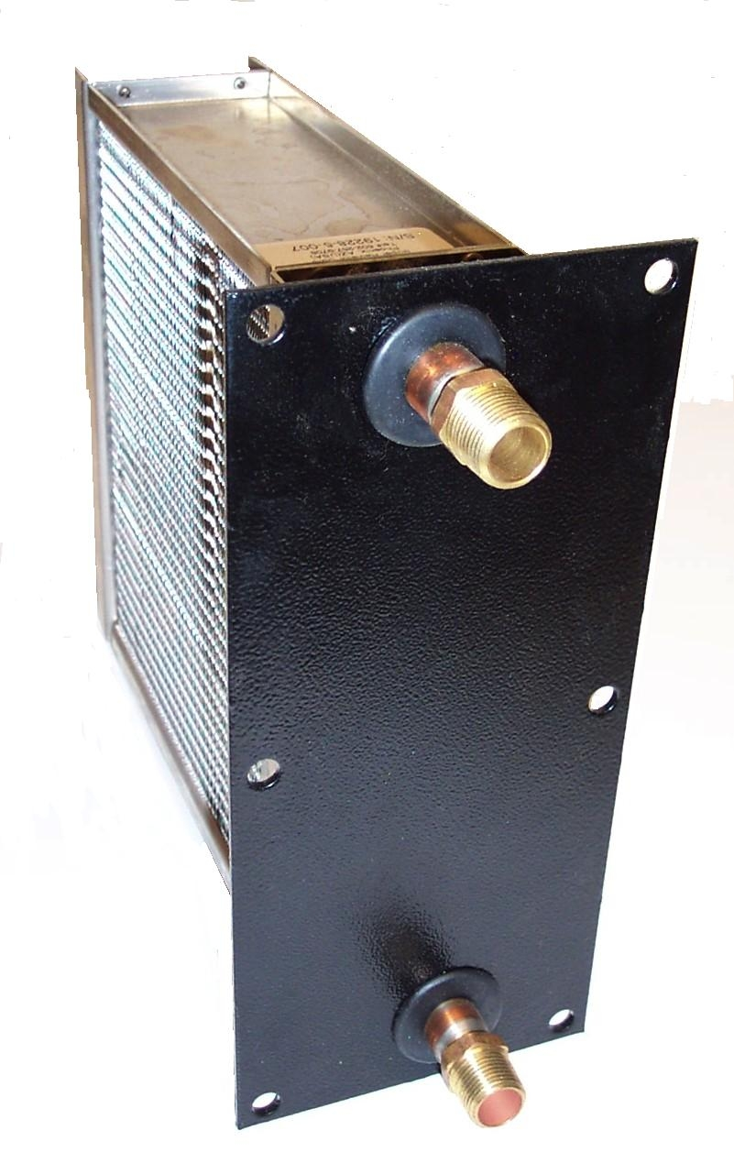

760619

Heat Exchanger – Preheater

Copper
Prochem: Legend GT

TEMPORARY
STOCK ITEM

790038

Manifold – Heat Exch - Fittings
Prochem: Apex, Blazer XL, Everest, Everest HP, Legend XL, Peak & Peak GTX

PP790801

Heat Exchanger – Preheater

Copper
Prochem: Blazer XL & Legend XL

TEMPORARY
STOCK ITEM

PP790388

Heat Exchanger – HP SS
Prochem: Apex, Blazer XL, Blazer GT, Everest, Everest HP, Legend XL Legend GT, Peak & Peak GTX

790343

Pad - Heat Exchanger Bottom
Prochem: Apex, Blazer XL, Everest, Everest HP, Everest 408 & 650, Legend XL & Peak

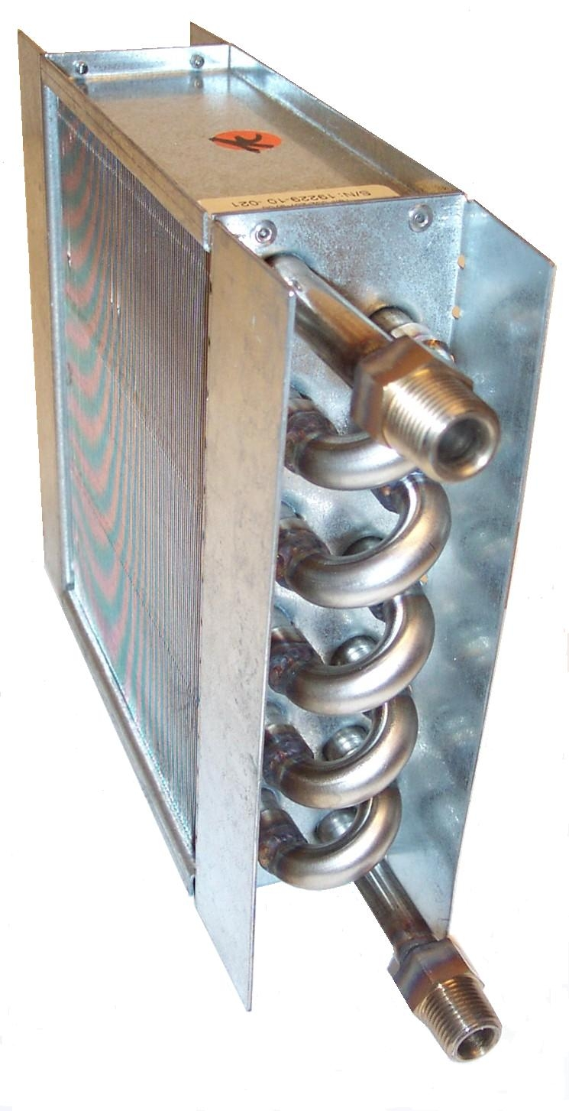
TEMPORARY
STOCK ITEM

PP790050

Gasket - Heat Exchanger Cover
Prochem: Apex, Blazer XL, Everest, Everest HP, Legend XL & Peak

790423

Pad - Heat Exchanger Rear
Prochem: Apex, Blazer XL, Everest, Everest HP, Legend XL & Peak

TEMPORARY
STOCK ITEM

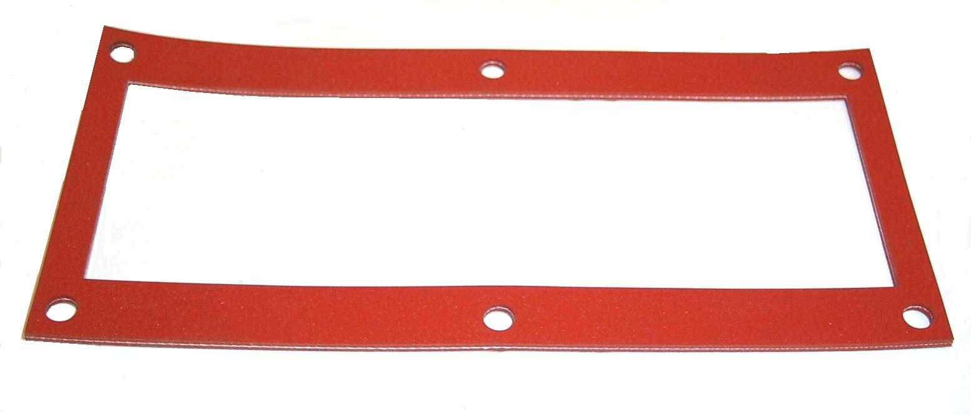

Bridgepoint Parts Catalog

Section XVIII: Heat Exchangers Page 3

PHY038-015

Heat Exchanger – CDS

Tube & Shell
Hydramaster: All CDS machines.

PHY038-045

Heat Exchanger Assembly

After Burner

Hydramaster: Maxx 450D & Maxx 470D
Bridgepoint: Javelin

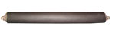

PHY038-052

Heat Exchanger- Salsa X
Hydramaster: CDS 4.8 & 4.6
(Old Style High Pressure Salsa X)
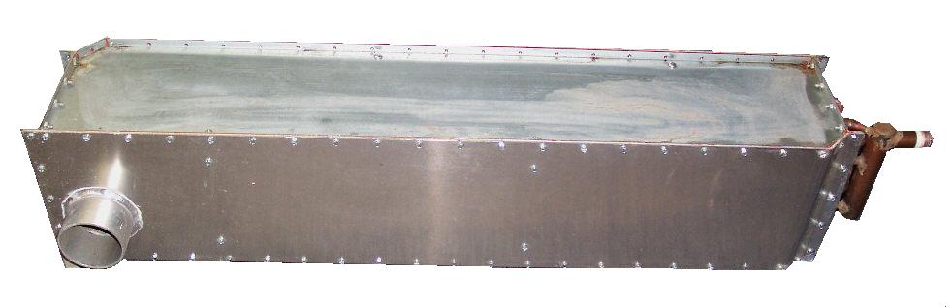

PHY038-054

Heat Exchanger Assembly

After Burner

Hydramaster: Boxxer 421

PHY038-031

Heat Exchanger - Preheater

4” Tube & Shell with 3” ends
Hydramaster: CDS 4.8 & 4.6 (Low Pressure Salsa Kit)
Maxx 450D & Maxx 470D
Bridgepoint: Javelin

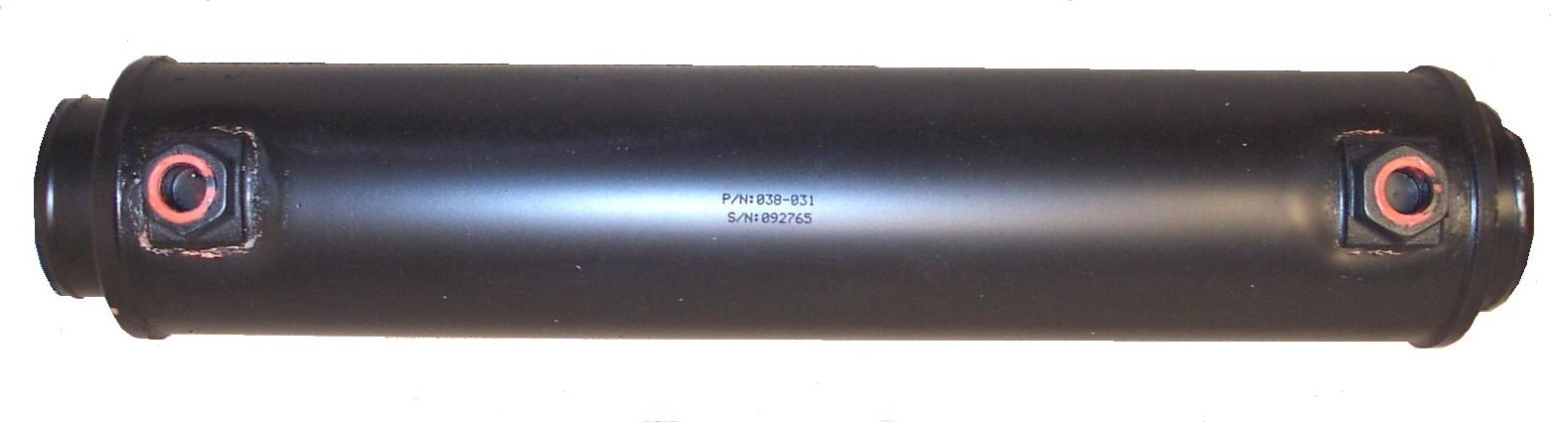

PHY093-066

Catalytic Converter - Heater

Hydramaster: Maxx 450D &
Maxx 470D
Bridgepoint: Javelin

PHY038-018

Heat Exchanger - Preheater

3” Tube & Shell

Hydramaster: Spitfire 3.2, Crossfire 4.2 & Crossfire 4.4
Bridgepoint: Dagger

PHY038-020

Heat Exchanger

Triple Stainless Steel

Hydramaster: Crossfire 4.2

PHY038-053

Heat Exchanger - Preheater
Hydramaster: Boxxer 421, CDS 4.6 & CDS 4.8
(New Style High Pressure Salsa X)

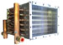

PHY038-030

Heat Exchanger

Quad Stainless Steel

Hydramaster: Crossfire 4.2XL & Crossfire 4.4

PHY038-055

Heat Exchanger

Blower Exhaust
Hydramaster: Boxxer 427

PHY038-026

Heat Exchanger

Dual Stainless Steel

Hydramaster: Spitfire 3.2
Bridgepoint: Dagger
Insulating Blanket: PHY108-023

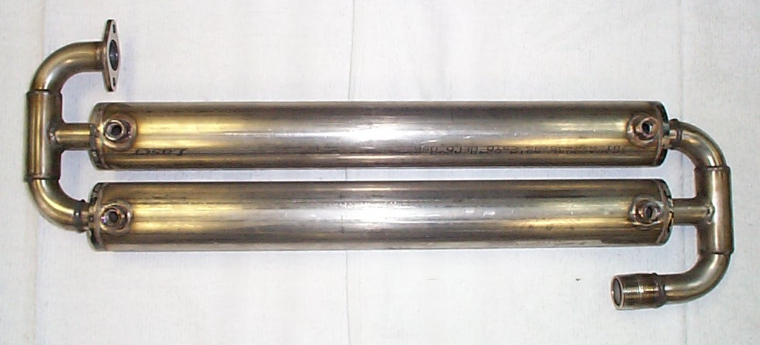

PHY038-028

Heat Exchanger - Preheater

4” Tube & Shell
Hydramaster: Spitfire 4.0
Gasket: PHY057-038
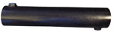

PHY038-027

Heat Exchanger

Triple Stainless Steel

Hydramaster: Spitfire 4.0

Insulating Blanket: PHY108-046

PHY038-043

Heat Exchanger 3” x 10”

Water to Water - Copper
Hydramaster: Crossfire 4.4,
Boxxer 427, Maxx450D
& Maxx 470D

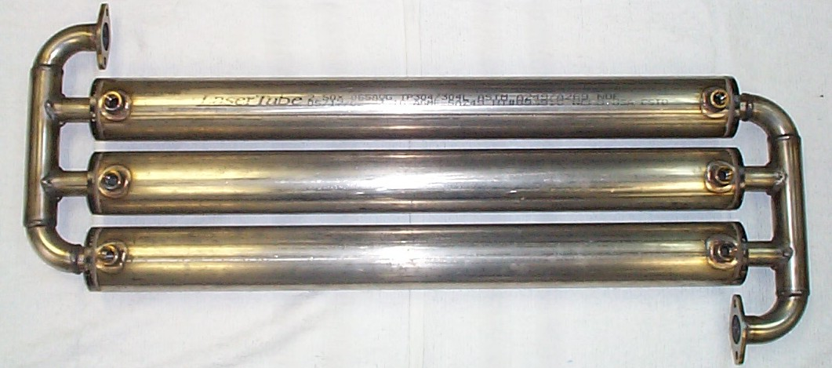

Bridgepoint Parts Catalog

Section XVIII: Heat Exchangers Page 4

PWM-HE1000-1

Heat Exchanger

Engine Coolant

White Magic: Pro1000, Pro1200, Pro2000 & Pro1900

PWM-PH3000

Heat Exchanger

Vulcan Post Heater

White Magic: Pro 1000 & Pro1200

PWM-HE2500-1

Heat Exchanger – Preheater

Blower Exhaust

White Magic: Pro1600

PWM-HE1500-1

Heat Exchanger

Engine Exhaust

White Magic: Pro1600

PWM-HE1800-1

Heat Exchanger

Engine Exhaust

White Magic: Pro1800

PWM-HE1900-1

Heat Exchanger

Engine Exhaust

White Magic: Pro1900

PWM-PH1500-1

Heat Exchanger – Preheater

Blower Exhaust

White Magic: Pro1800

PHY113-002

Radiator – Heat Exchanger

Preheater
Hydramaster: Spitfire 3.2 & 4.0

Bridgepoint: Dagger

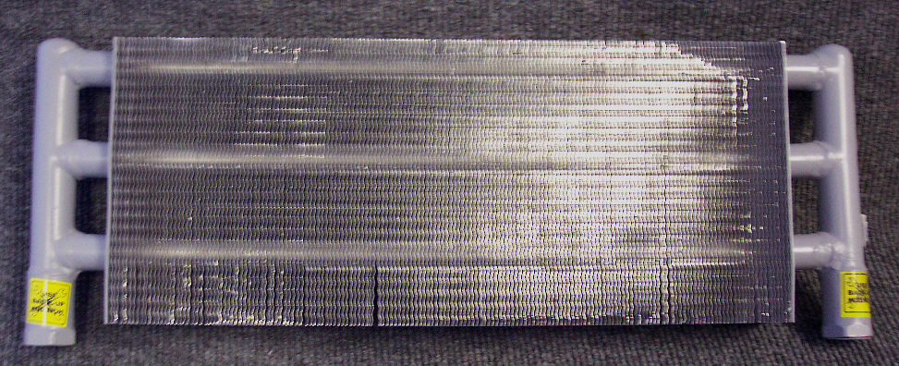

PWM-D0026

Gasket – Exhaust to Heat

Exchanger & Diverter
White Magic: Pro1600, Pro1800 & Pro1900

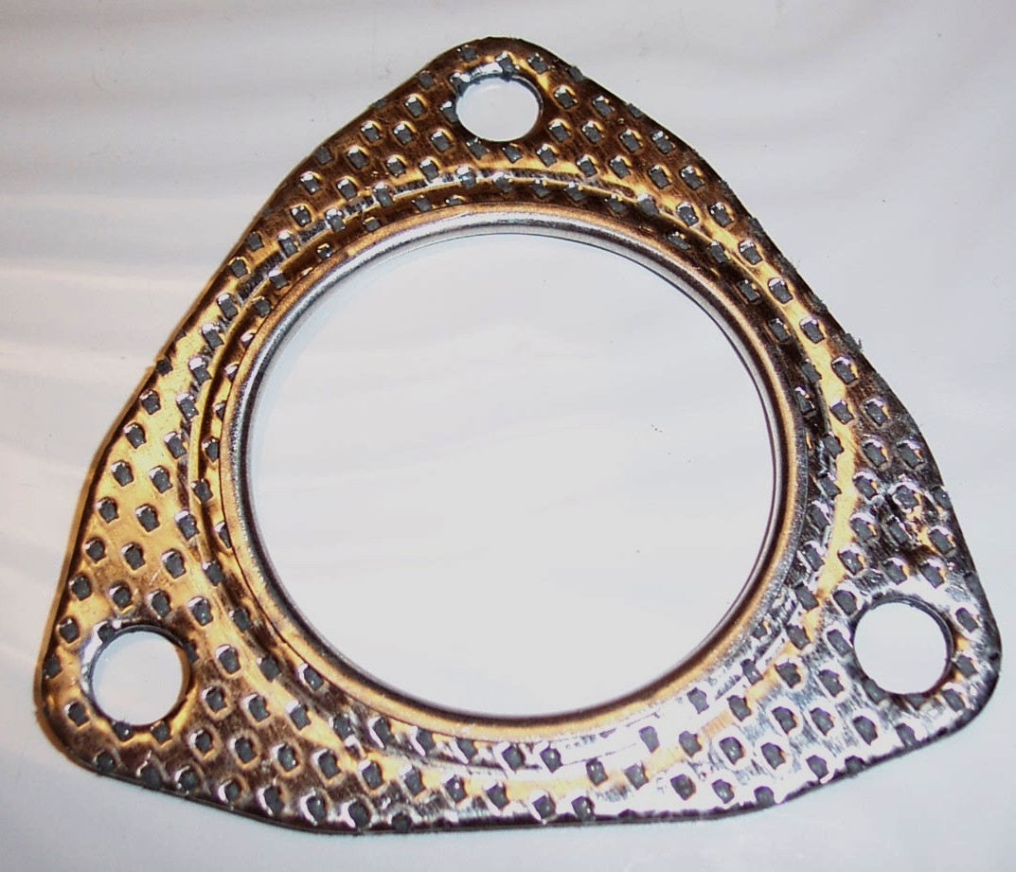

PP57-520061

Heat Exchanger – Preheater

Radiator
Prochem: Bruin
Bridgepoint: Lancer
(Old style units with Onan engine)

PP61-951461

Heat Exchanger – Preheater

Prochem Performer 805

Blower Exhaust

High Pressure
Gasket: PP43-807119
Pad: PP58-700036

PP61-951278

Heat Exchanger – Preheater

Prochem PTO

Blower Exhaust

High Pressure

Gasket – PP 43-807081
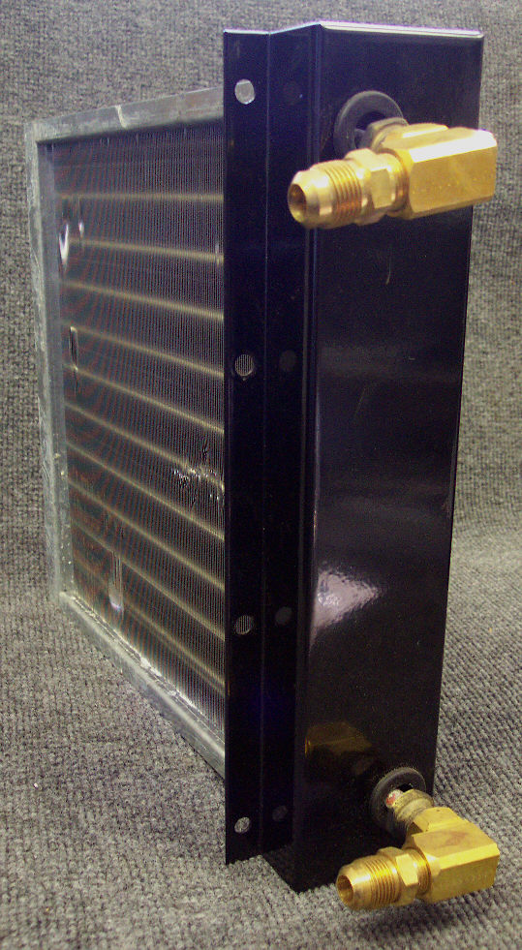

PHY131-037

Fiberglass Wrap 2” x 50’
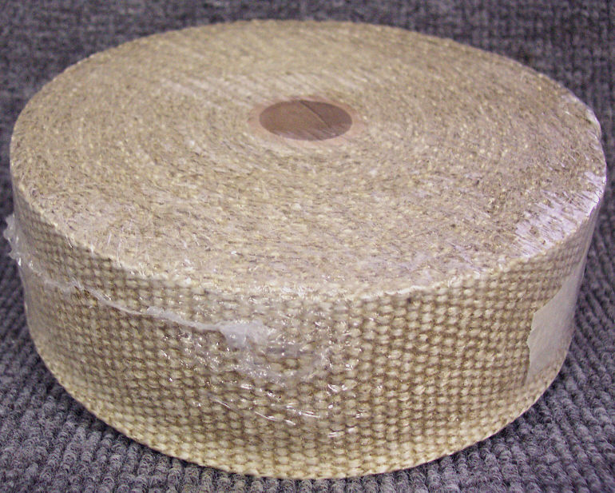

PHY131-046

Insulation Sleeve .054 x 1-1/2”
Sold by the Foot

PHY131-044

Insulation Sleeve .065 x 2”
Sold by the Foot

PHY057-146

Gasket – Diverter Valve

PHY057-177

Gasket – Exhaust Donut 1-1/2”

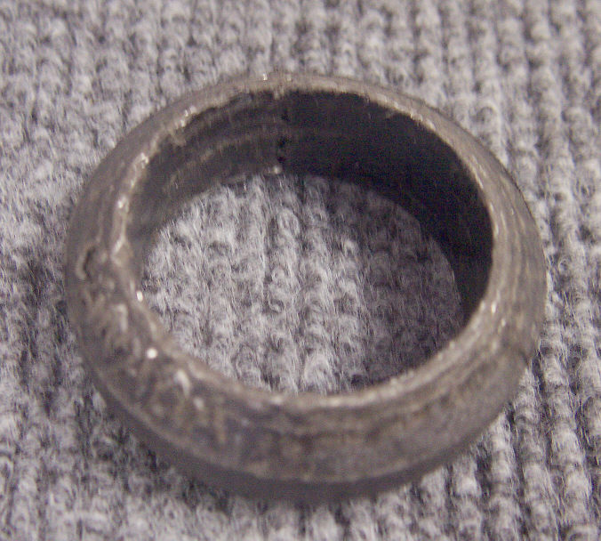
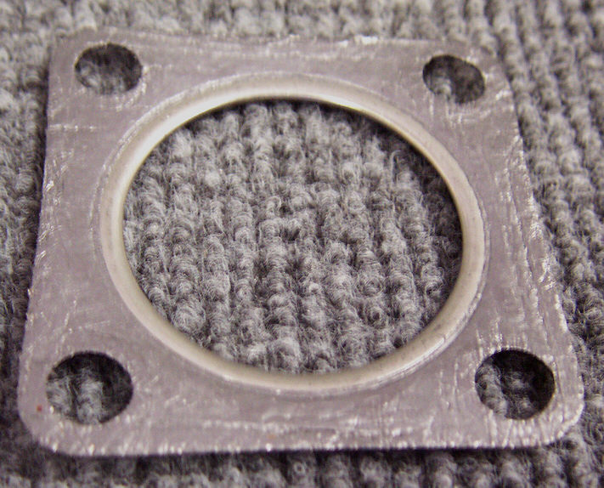

Bridgepoint Parts Catalog

Section XVIII: Heat Exchangers Page 5

NM5043

Heat Exchanger – Electric
Single Element – Dual Thermostats
1750 watt
Olympus: M100H & M500H

NM5044

Heat Exchanger – Electric
Dual Elements – Quad Thermostats
2000 watt
Olympus: M3-200H & M200H

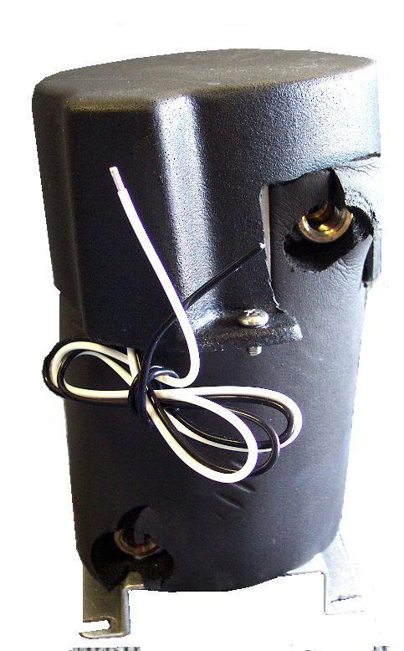

MB212

TEX Thermal Exchanger

Complete
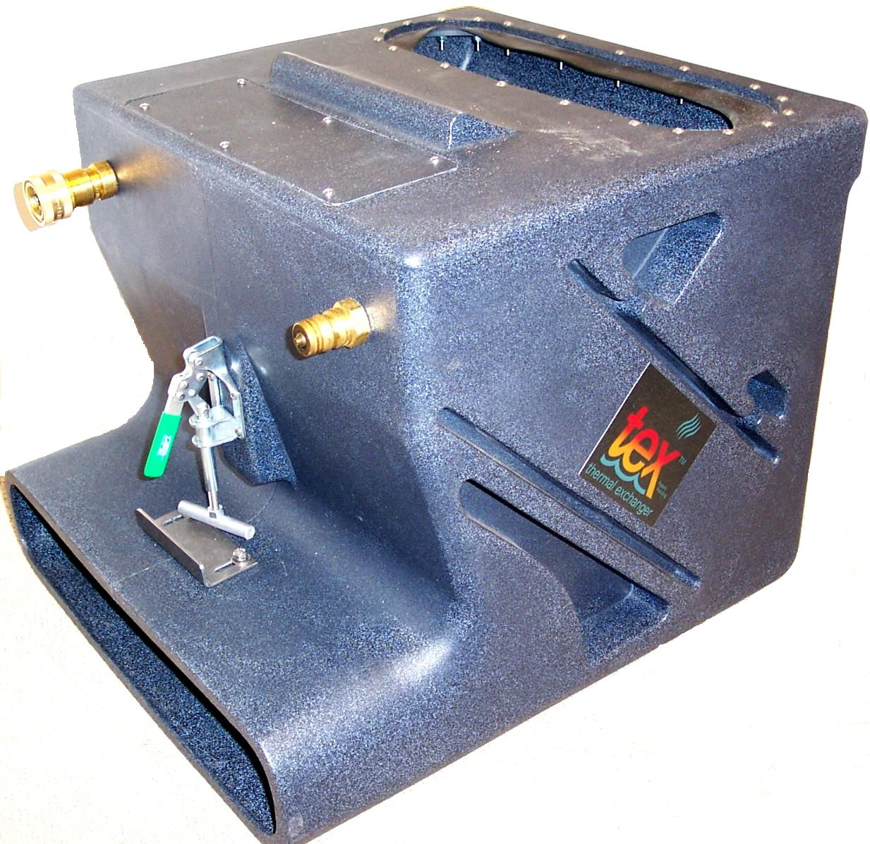

NM5083

Heat Exchanger – Electric
Single Element – Dual Thermostats
1000 watt
Olympus: M3-100H

NM4250

Body TEX Thermal Exchanger

Roto-molded Plastic w/ brace

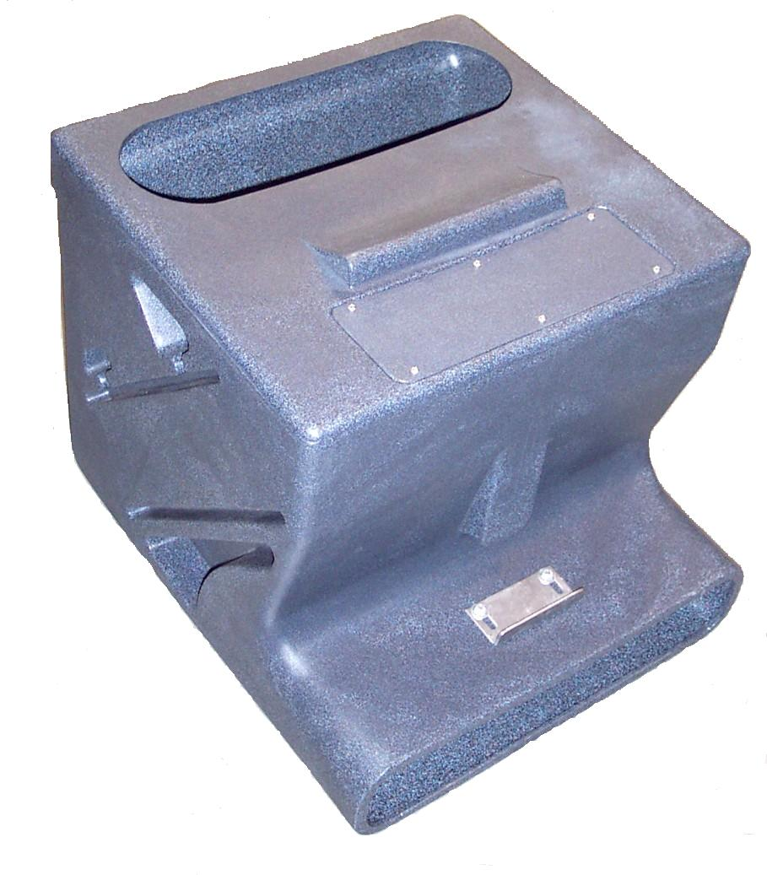
Discontinued
Discontinued
Discontinued
Discontinued
Discontinued

NM4444

Heating Element E-TES 240V

1550 Watt

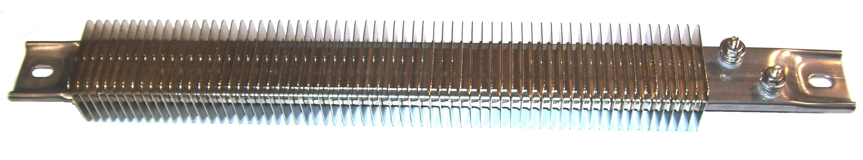

NM4251

Body E-TES SD

Roto-molded Plastic

NM4445

Heating Element E-TES 120V

1000 Watt

NM4453

Heating Element E-TES 120V

750 Watt

NM5922

Heating Element E-TES 240V

5760Watt

NM4252

Coil TEX Thermal Exchanger

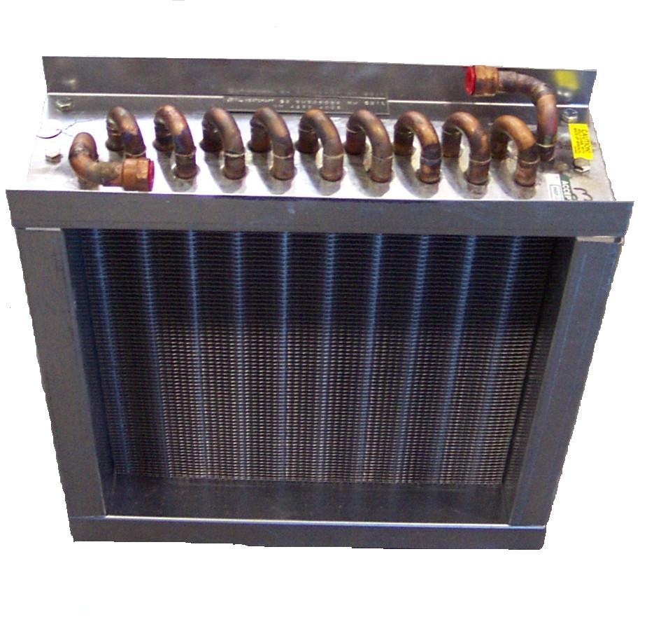

NM5920

Heating Element E-TES 120V

3000Watt

PSA100910

Heat Exchanger – Electric

600W Power X Spotter
Element: PSA101500B
Shell: PSA100900

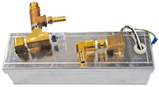
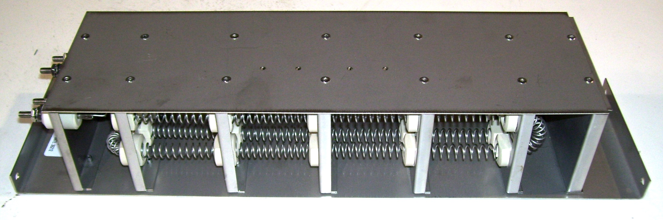

(Comes with fittings)

PP57-520069

Heat Exchanger – Exhaust

Non catalytic
Bridgepoint: System IV – older style
NO LONGER AVAILABLE

NM5900

Body E-TES SD Low Profile

Roto-molded Plastic w/ brace

PP57-520059

Heat Exchanger – Exhaust

Non catalytic
Prochem: Cub XL
NO LONGER AVAILABLE

PP57-520056

Heat Exchanger – Exhaust

Non catalytic
Prochem: Bruin – older style
Bridgepoint: Lancer – older style
NO LONGER AVAILABLE

PP57-520049

Heat Exchanger – Exhaust

Non catalytic
Prochem: Cub

NO LONGER AVAILABLE

PP57-520046

Heat Exchanger – Exhaust

Non catalytic
Prochem: 800A

PP57-520006

Heat Exchanger – Exhaust

Non catalytic
Prochem: 65C, 75

NO LONGER AVAILABLE

NO LONGER AVAILABLE

